Name : Manish Birhade | Batch- DA November 2024

Project Title: Sales Performance Analysis.

This project involves working with a Sales dataset and includes tasks using SQL, Pandas, and Power BI to analyze sales trends,

customer behavior, and product performance.

Project Overview

A retail company wants to analyze its sales performance across different regions, products, and time periods. Your task is to:

Extract & manipulate data using SQL.

Process & analyze data using Pandas in Python.

Visualize insights using Power BI.

1️.SQL Task – Data Extraction & Manipulation

- Retrieve total sales per region.

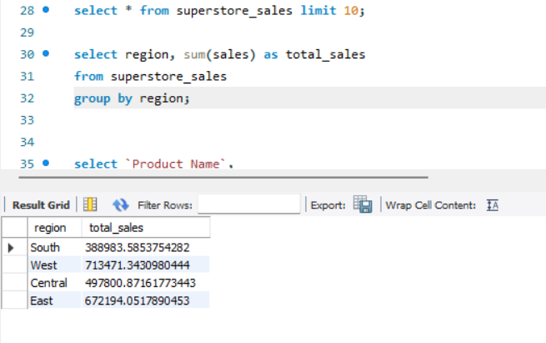

- Find the top 5 best-selling products.

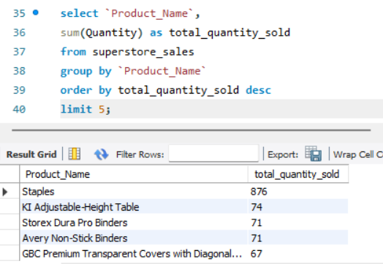

- Calculate monthly revenue.

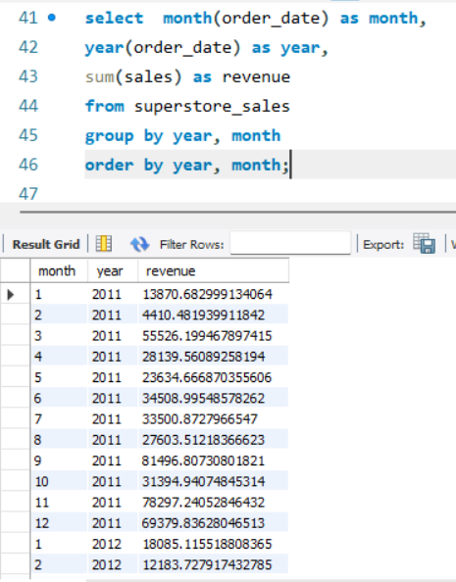

- Identify repeat customers.

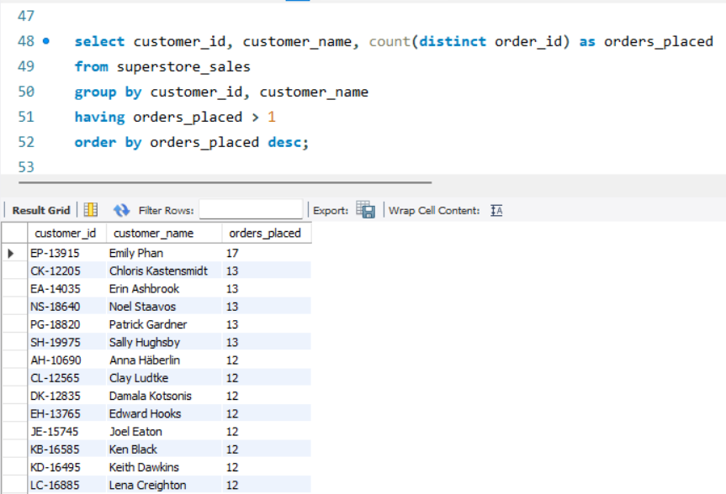

2️.Pandas Task – Data Processing & Analysis

- Load the dataset into DataFrames.

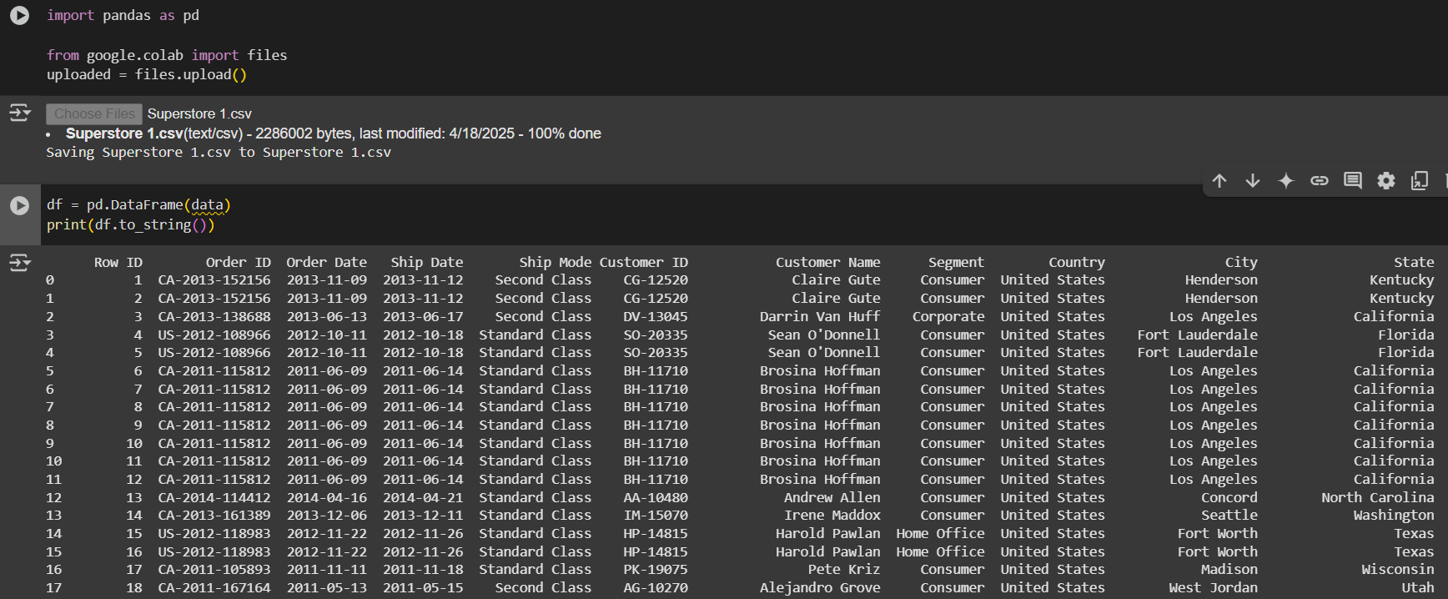

- Handle missing values & data cleaning.

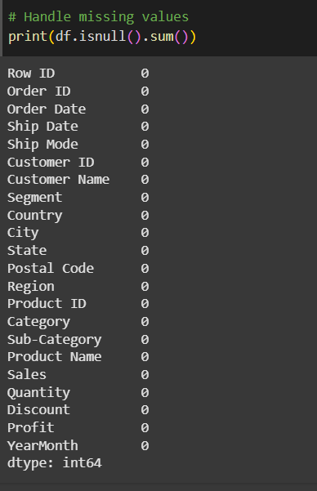

No Missing Value this dataset.

- Analyze total sales per customer.

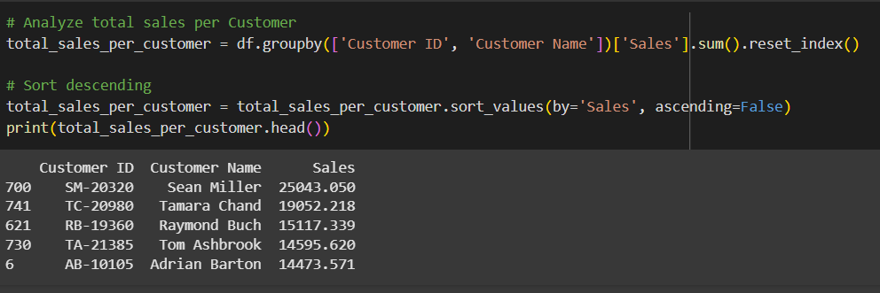

- Calculate moving average sales per month.

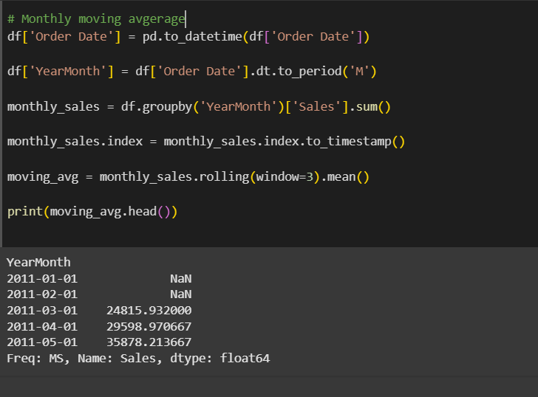

3️.Power BI Task – Data Visualization

- A sales dashboard with revenue trends.

- A product performance analysis chart.

- A customer segmentation analysis based on age/gender.

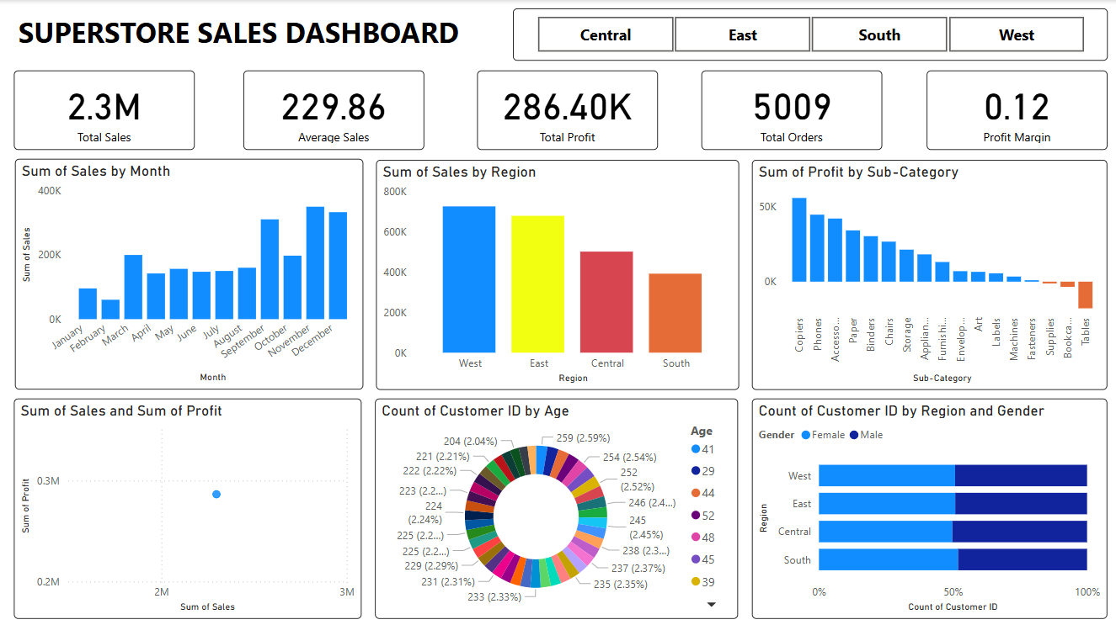

Final dataset should be insightful and meaningful.

Dataset: You need to search dataset from any website(eg. kaggle)

**Summary:**

This project involved analyzing Superstore sales data using Power Bi and Excel. The focus was on visualizing sales trends, evaluating products performance, and segmenting customers based on age and gender.

**Conclusion :**

* Sales peak during the end of the year (November-December.
* The Technology category generates the highest revenue.
* The west region has the highest number of customers.
* The distribution of male and female customers is balanced.